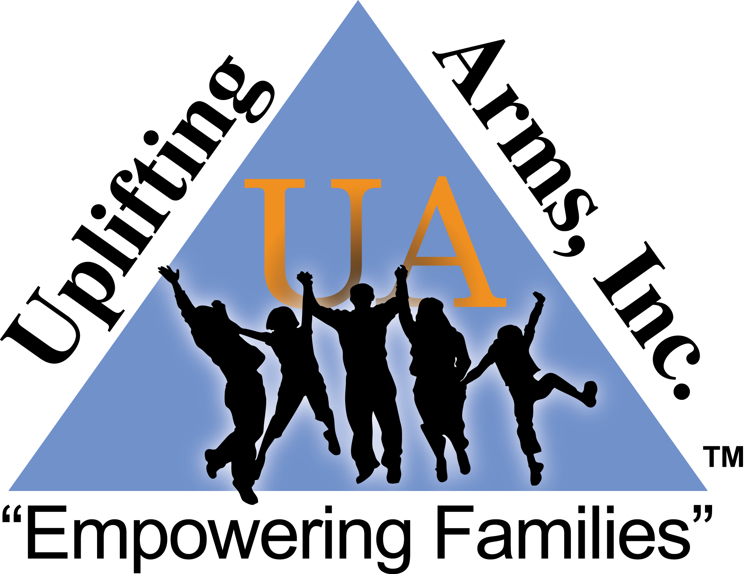  Educating, Exposing, Equipping, and Empowering Families  The nonprofit, Uplifting Arms Inc., along with I Empower, LLC, are hosting our  4th Annual  Dyslexia Awareness Fundraising Gala  We will honor a student with the 2026 Lamonté Spencer Memorial Award  There will be a Silent Auction and Door Prizes!  The evening’s event is a Black-Tie Affair, so dress in your finest and come out to help us raise awareness of Dyslexia.  Tickets are $40  Mailing address:  610 Grants Ferry Rd. Unit 5444 Brandon, MS 39047  admin@upliftingarms.org www.upliftingarms.org  Location:  Lineage Lakes Clubhouse  134 Lineage Lane | Dear Community Partner,  I’m Nefertiti Harris, Founder and Executive Director of Uplifting Arms, Inc. and CEO of I Empower, LLC. I’m writing to invite you to be part of something truly meaningful, which is our 4th Annual Dyslexia Awareness Fundraising Gala.  One in five people live with dyslexia, yet many families still struggle to find answers, support, and hope. Through your sponsorship, you help us change that. Your support allows us to:  - Equip parents and educators with the tools to recognize the signs of dyslexia early.  - Provide reading programs to families who need them most.  - Grow Empowered Prep Academy, our newly opened microschool designed specifically to give students with dyslexia a flexible and supportive learning environment.  The Gala will take place on Saturday, October 24, 2026, from 5:00–8:00 p.m. at the Lineage Lake Clubhouse (134 Lineage Lane) in Flowood, MS. It will be an evening of empowerment, connection, and community impact.  We would be honored to stand alongside your business as a sponsor. Together, we can shine a light on dyslexia and open doors of opportunity for children and families right here in Mississippi.  Below are our Sponsor Packages:  $1500.00 PLATINUM SPONSOR:  This sponsorship level includes a table of 8 at the event, your business announced on social media, your logo displayed on multiple tables at the event and on our website, a digital ad displayed during the event, your name on the event program and your provided brochures/literature or company paraphernalia on display for the patrons at the event.  $1000.00 GOLD SPONSOR:  This sponsorship level includes 4 tickets for the event, your business announced on social media, your logo displayed on a table at the event, a digital ad displayed during the event, your name on the event program and your provided brochures/literature or company paraphernalia on display for the patrons at the event.  $500.00 SILVER SPONSOR  This sponsorship level includes 2 tickets for the event, your business announced on social media, your logo displayed on a table at the event, your name on the event program, and your provided brochures/literature or company paraphernalia on display for the patrons at the event.  Please confirm your sponsorship choice by September 25, 2026. Checks should be made payable to Uplifting Arms, Inc., or you can pay via Credit or Debit Card through PayPal on our website. If more information is needed, please contact Nefertiti Harris at (769) 228-6436 or via email at nharris@upliftingarms.org for more information. Thank you for your time and consideration. I look forward to hearing from you soon.  With gratitude,  Nefertiti Harris, Founder and Executive Director  Uplifting Arms, Inc. and I Empower, LLC

